SINGLE INHERITANCE:
- INHERITANCE:


Her I have created a class Employ(child class) which inherits the features from class Person(Parent class).

2. Method overriding:


get_pay method in the parent class got overriding by the get_pay method in the child class.
3.Super()


__init__() method from class SalesEmployee calls the __init__() method in class Employee to initialize the name, base_pay, bonus


Error:
Unsupported operand type

Solution:
I have to call a function using ()
In line 14 - “return super().get_pay() + sales_incentive”


4. __slots__
Python uses dictionaries to store instances of a class.
Which makes memory overhead.
To optimizes we use the __slots__

We can see the instance that are __slots__ and __dict__.
4.Abstract Classes:
We use abstract class to share the code among several closely related class.
In the below program all the subclasses of the Employee class share the same full_name property.
To use abstract classes import abc module.
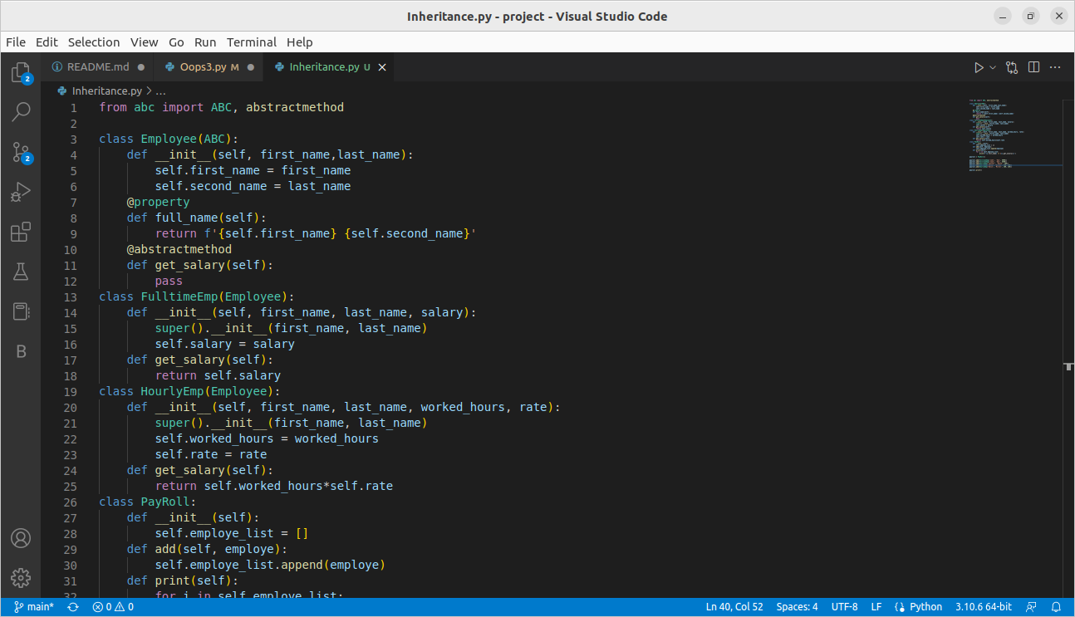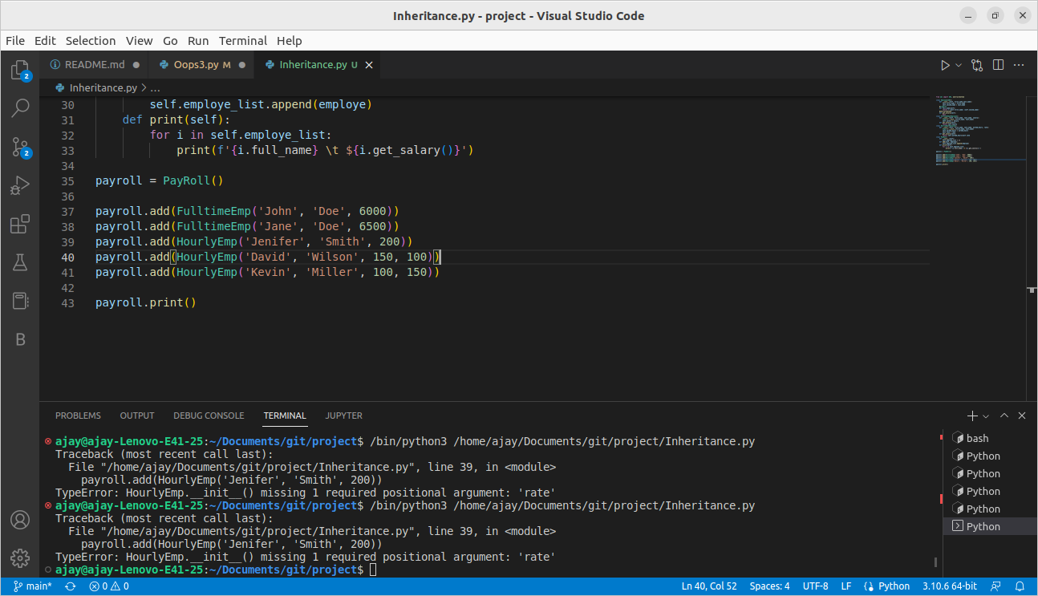
Error:
TypeError Missing 1 required positional argument.
Solution:
In HourlyEmp there are 4 instance but I have given only 3 instance
